**HAP 780-001**

**MIMIC III DATASET EXPLORATION IN SQL AND WEKA**

Abhishek Shambhu

**Prediction of Mortality for Patients admitted in first 24 hours to hospital based on top 25 Lab Events**

**Source Code:**

---1. Preprocessing the Admissions table

--- so as to have only one random HADM_ID for one SUBJECT_ID.

--- Creating random number based on HADM_ID. Since HADM_ID is unique which will create unique random numbers.

SELECT [SUBJECT_ID], [HADM_ID], [ADMITTIME], [ETHNICITY], [DIAGNOSIS], [HOSPITAL_EXPIRE_FLAG], RAND([HADM_ID]) AS RANDOM_NO

INTO [mimic].[dbo].ADMISSIONS_TEMP1

FROM [mimic].[dbo].[ADMISSIONS];

--- 58976 rows affected

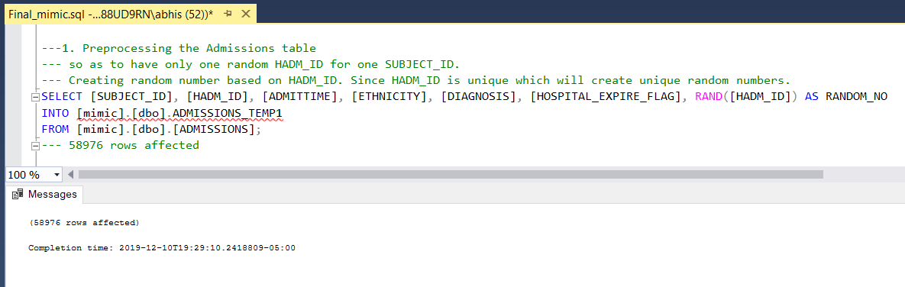

--- Assigning Min random number to each subject_id

SELECT [SUBJECT_ID], MIN(RANDOM_NO) AS MIN_RANDOM_NO

INTO [mimic].[dbo].ADMISSIONS_TEMP2

FROM [mimic].[dbo].ADMISSIONS_TEMP1

GROUP BY [SUBJECT_ID];

--- 46520 rows affected

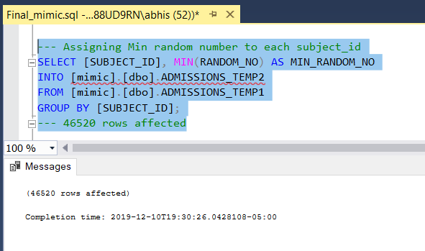

--- Combining the two tables based on Min Random Number and performing cleaning of [HOSPITAL_EXPIRE_FLAG] and [DIAGNOSIS]

SELECT T1.[SUBJECT_ID], [HADM_ID], [ADMITTIME], [ETHNICITY], [DIAGNOSIS], [HOSPITAL_EXPIRE_FLAG]

INTO [mimic].[dbo].ADMISSIONS_PROCESSED

FROM [mimic].[dbo].ADMISSIONS_TEMP1 T1

INNER JOIN

[mimic].[dbo].ADMISSIONS_TEMP2 T2

ON RANDOM_NO=MIN_RANDOM_NO

WHERE [HOSPITAL_EXPIRE_FLAG] = '0' OR [HOSPITAL_EXPIRE_FLAG] = '1' AND [DIAGNOSIS] <> ''; --- 45472 rows

---

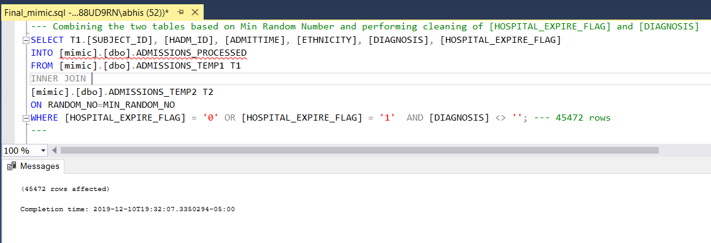

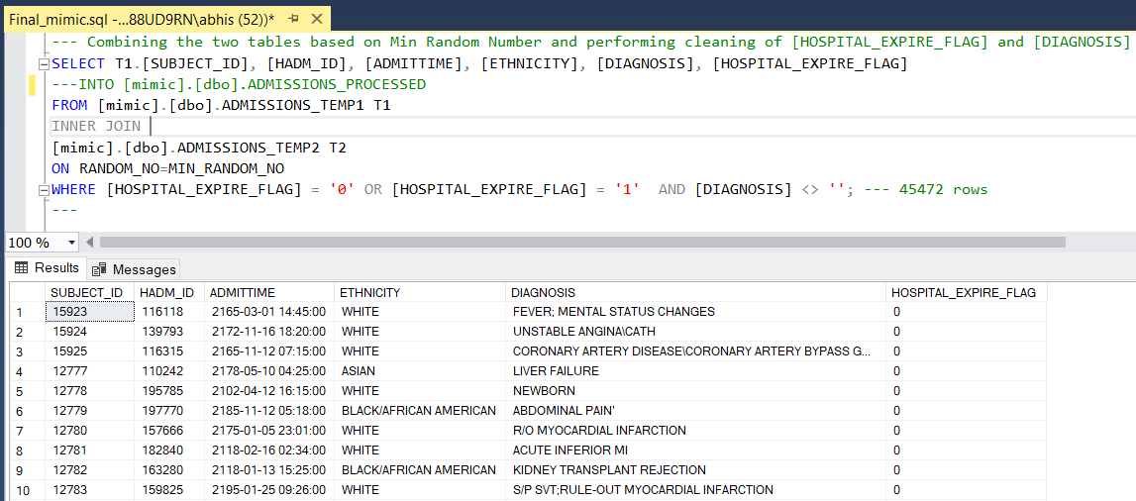

--- Getting count of Mortality from Admissions Table

SELECT COUNT(*)

FROM [mimic].[dbo].ADMISSIONS_PROCESSED

WHERE [HOSPITAL_EXPIRE_FLAG] = 1; --- 4815

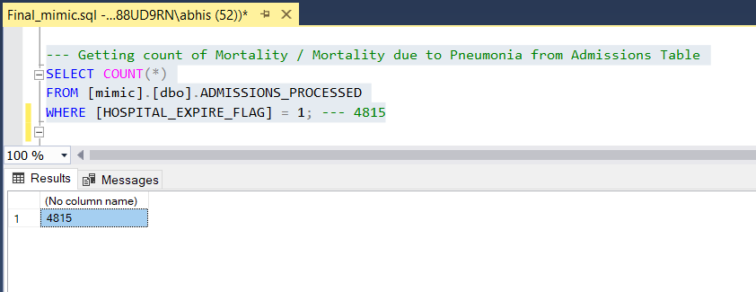

---2. Patients table

SELECT [SUBJECT_ID], [GENDER], [DOB], [EXPIRE_FLAG]

FROM [mimic].[dbo].PATIENTS;

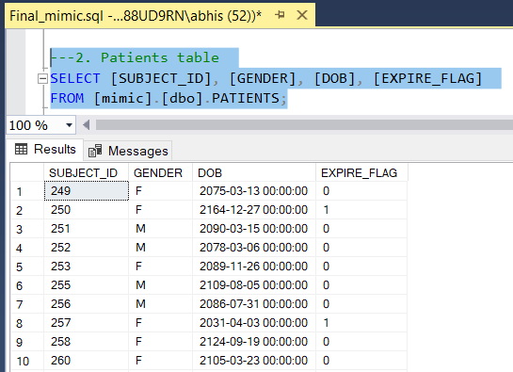

---3. Joining Processed Admissions Table with the Patients Table

SELECT ap.[SUBJECT_ID], [HADM_ID], [ADMITTIME], [ETHNICITY], [DIAGNOSIS], [HOSPITAL_EXPIRE_FLAG], [GENDER], [DOB], [EXPIRE_FLAG]

INTO [mimic].[dbo].COMB_ADM_PAT_RAW1

FROM [mimic].[dbo].[ADMISSIONS_PROCESSED] ap

LEFT JOIN

[mimic].[dbo].PATIENTS p

ON ap.SUBJECT_ID = p.SUBJECT_ID; --- 45472 rows

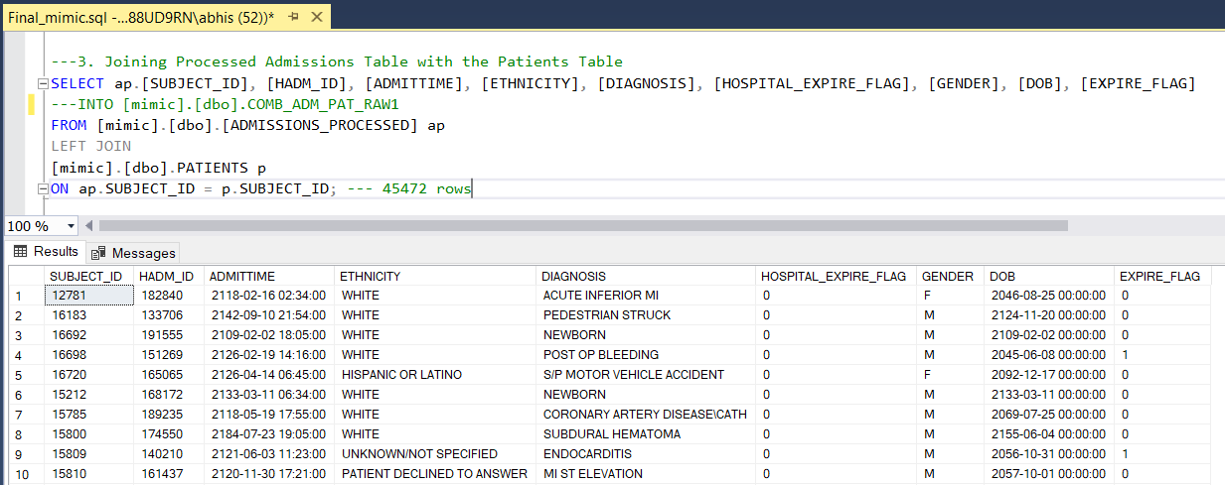

---4. Since we have DOB and ADMITTIME, we calculate the Age

--- Converting String to Datetime type for dates

SELECT [SUBJECT_ID], [HADM_ID], ADMITTIME, CAST(ADMITTIME AS datetime) AS ADMITTIME_DATE, [ETHNICITY], [DIAGNOSIS],

[HOSPITAL_EXPIRE_FLAG], [GENDER], DOB, CAST(DOB AS datetime) AS DOB_DATE, [EXPIRE_FLAG]

INTO [mimic].[dbo].COMB_ADM_PAT_RAW2

FROM [mimic].[dbo].COMB_ADM_PAT_RAW1; --- 45472 rows

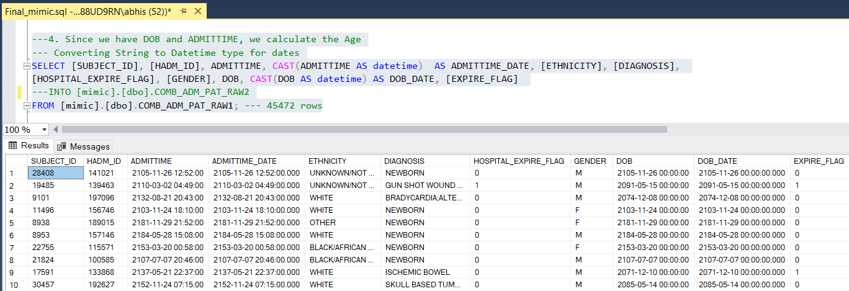

--- Taking difference for calculating age --- Here I am avoiding mm and dd complexity for age and just using year

SELECT [SUBJECT_ID], [HADM_ID], ADMITTIME_DATE, [ETHNICITY], [DIAGNOSIS],

[HOSPITAL_EXPIRE_FLAG], [GENDER], DOB, [EXPIRE_FLAG], (DATEPART(year, ADMITTIME_DATE) - DATEPART(year, DOB_DATE)) as AGE

INTO [mimic].[dbo].COMB_ADM_PAT

FROM [mimic].[dbo].COMB_ADM_PAT_RAW2; --- 45472 rows

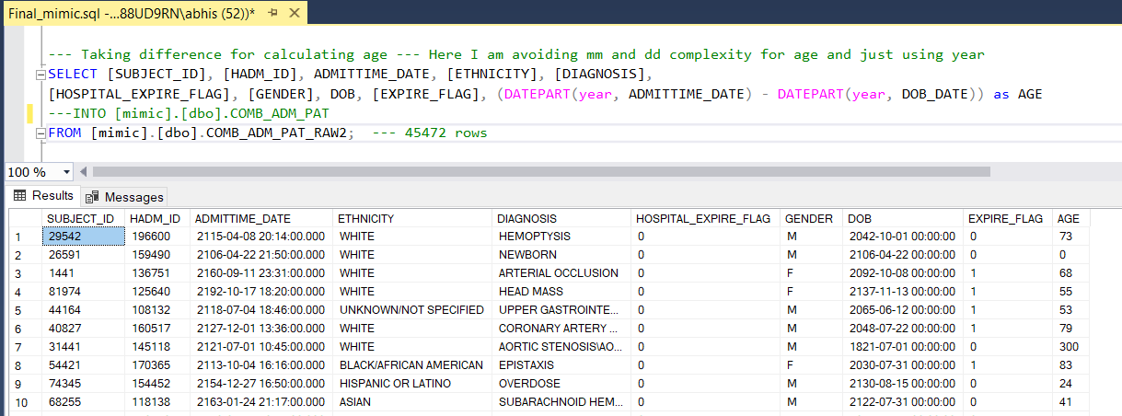

--- Now since we have Age we go forward to assign classes to Age (Age category)

--- 0-1 --> Neonate 15-59 --> Adult 60-89 --> Senior Adult 89+ --> >89

SELECT [SUBJECT_ID], [HADM_ID], ADMITTIME_DATE, [ETHNICITY], [DIAGNOSIS], [HOSPITAL_EXPIRE_FLAG], [GENDER], DOB, [EXPIRE_FLAG], [AGE]

, CASE

-- all ages > 89 in the database were replaced with 300

WHEN [AGE] <= 1

THEN 'NEONATE' --- 7874 rows

WHEN [AGE] > 14 AND [AGE] <=59

THEN 'ADULT' --- 14017 rows

WHEN [AGE] > 59 AND [AGE] <=89

THEN 'SENIOR ADULT' --- 21645 rows

ELSE '>89' --- 1936 rows

END AS AGE_CATEGORY

INTO [mimic].[dbo].COMB_ADM_PAT_AGECAT

FROM [mimic].[dbo].COMB_ADM_PAT

ORDER BY [SUBJECT_ID]; --- 45472 rows

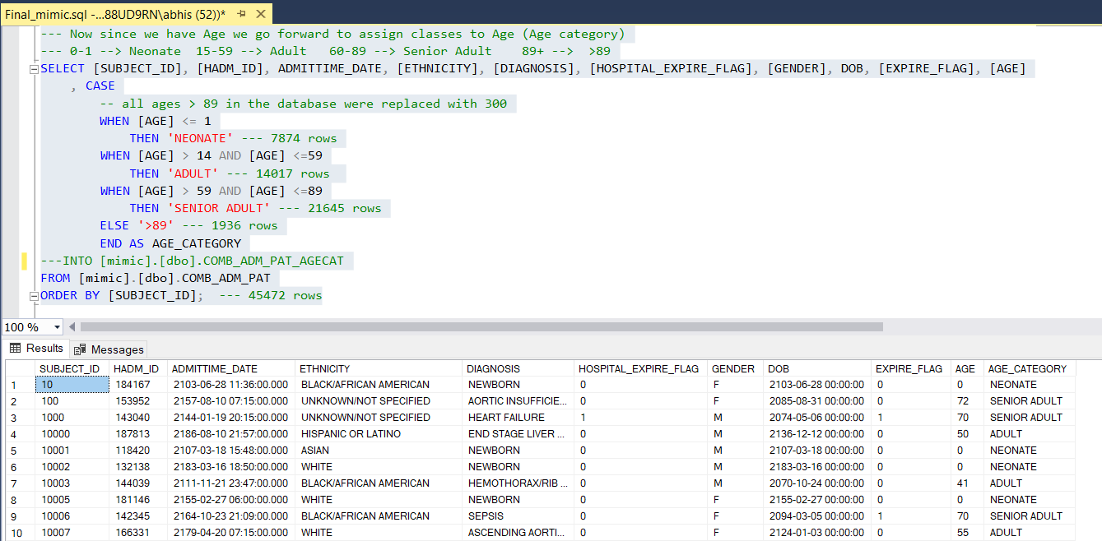

--- Reducing 41 Ethnicity classes to top 4 classes

SELECT [SUBJECT_ID], [HADM_ID], [GENDER], [DOB], [ADMITTIME_DATE], [AGE], [AGE_CATEGORY],

CASE WHEN lower(ethnicity) like '%white%'

THEN 'WHITE'

WHEN lower(ethnicity) like '%black%'

THEN 'BLACK'

WHEN lower(ethnicity) like '%asian%'

THEN 'ASIAN'

WHEN lower(ethnicity) like '%hispanic%'

THEN 'HISPANIC/LATINO'

ELSE 'OTHERS'

END AS ETHNICITY_CATEGORY,

[HOSPITAL_EXPIRE_FLAG], [EXPIRE_FLAG]

INTO [mimic].[dbo].COMB_ADM_PAT_ETHCAT

FROM [mimic].[dbo].COMB_ADM_PAT_AGECAT; --- 45472 rows affected

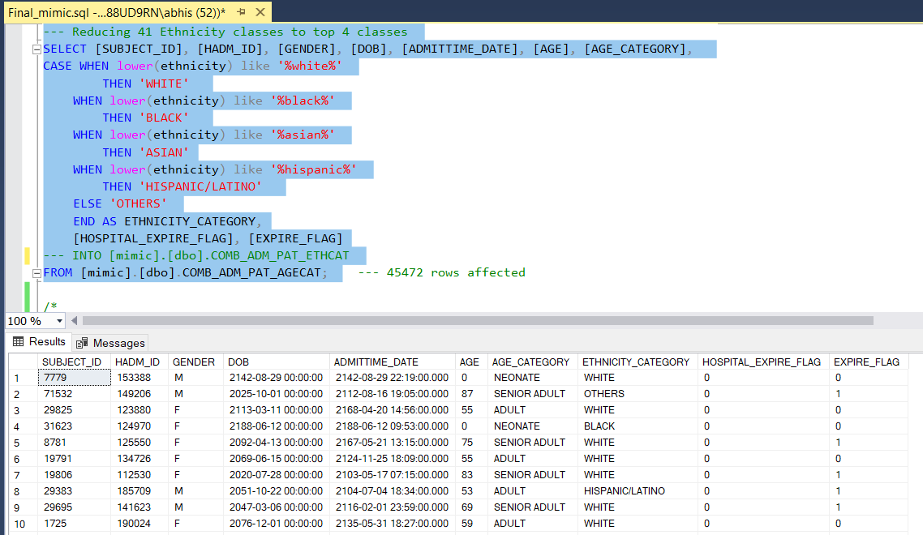

/*

select [SUBJECT_ID], [HADM_ID], [GENDER], [DOB], [ADMITTIME_DATE], [AGE],

CASE WHEN [AGE_CATEGORY]='NEONATE' THEN 1 ELSE 0 END as 'NEONATE',

CASE WHEN [AGE_CATEGORY]='ADULT' THEN 1 ELSE 0 END as 'ADULT',

CASE WHEN [AGE_CATEGORY]='SENIOR ADULT' THEN 1 ELSE 0 END as 'SENIOR ADULT',

CASE WHEN [AGE_CATEGORY]='>89' THEN 1 ELSE 0 END as '>89',

CASE WHEN [ETHNICITY_CATEGORY]='WHITE' THEN 1 ELSE 0 END as 'WHITE',

CASE WHEN [ETHNICITY_CATEGORY]='BLACK' THEN 1 ELSE 0 END as 'BLACK',

CASE WHEN [ETHNICITY_CATEGORY]='ASIAN' THEN 1 ELSE 0 END as 'ASIAN',

CASE WHEN [ETHNICITY_CATEGORY]='HISPANIC/LATINO' THEN 1 ELSE 0 END as 'HISPANIC/LATINO',

CASE WHEN [ETHNICITY_CATEGORY]='OTHERS' THEN 1 ELSE 0 END as 'OTHERS',

[HOSPITAL_EXPIRE_FLAG], [EXPIRE_FLAG]

into [mimic].[dbo].COMB_ADM_PAT_ETHCAT1

from [mimic].[dbo].COMB_ADM_PAT_ETHCAT; ----45472 rows

*/

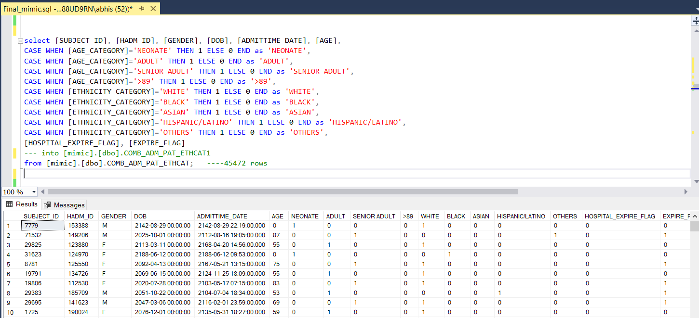

Select * from [mimic].[dbo].COMB_ADM_PAT_ETHCAT; --- 45472 rows

-----------------------------------------------------------------------------------------------------------

--- Taking Lab events of patients

SELECT * FROM [mimic].[dbo].[LABEVENTS]

/*

--- 1% of the Lab events data

select * from [mimic].[dbo].[LABEVENTS] tablesample(1 percent) --- Not as random as newid() but will give fast results --- 275701 rows

--- select top 1 percent * from [mimic].[dbo].[LABEVENTS] order by newid()

--- Creating LABEVENTS_SAMPLE_RAW(1%) file

select * INTO [mimic].[dbo].LABEVENTS_SAMPLE_RAW from [mimic].[dbo].[LABEVENTS] tablesample(1 percent) --- 274089 rows affected

--- select top 1 percent * INTO LABEVENTS_SAMPLE_RAW from [mimic].[dbo].[LABEVENTS] order by newid()

select * FROM [mimic].[dbo].LABEVENTS_SAMPLE_RAW;

*/

--- Preprocessing LabEvents data

--- To remove quotes

SET QUOTED_IDENTIFIER OFF

UPDATE [mimic].[dbo].[LABEVENTS]

SET [VALUEUOM] = REPLACE([VALUEUOM],"""","")

SET QUOTED_IDENTIFIER ON --- 27854055 rows affected

SET QUOTED_IDENTIFIER OFF

UPDATE [mimic].[dbo].[LABEVENTS]

SET VALUENUM = REPLACE(VALUENUM,"'","")

SET QUOTED_IDENTIFIER ON --- 27854055 rows affected

--- 1. Considering only in patient data(Removing all nulls from HADM_ID & nulls from Valuenum column)

---Removing all negative valuenum and preparing final Labevents table

select [SUBJECT_ID], [HADM_ID], [ITEMID], CAST([CHARTTIME] AS datetime) AS CHARTTIME_DATE, [VALUENUM], [VALUEUOM]

INTO [mimic].[dbo].LABEVENTS_PROCESSED

FROM [mimic].[dbo].[LABEVENTS]

WHERE HADM_ID <> '' AND VALUENUM not like '%-%' AND [VALUENUM] <> '' AND [VALUEUOM] <> ''; --- 19041736 rows

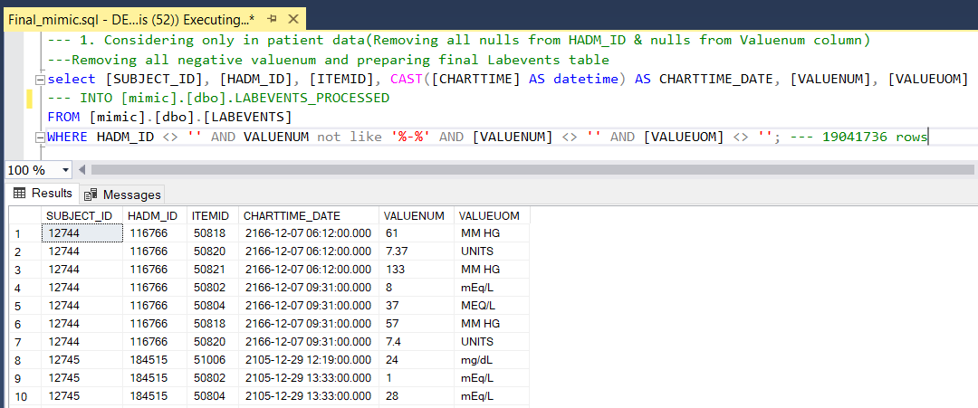

---- LAB events within 24 hours of admission

select a.[SUBJECT_ID], a.[HADM_ID], [GENDER], [DOB], [ADMITTIME_DATE], [AGE], [AGE_CATEGORY], [ETHNICITY_CATEGORY],

[DIAGNOSIS], [HOSPITAL_EXPIRE_FLAG], [EXPIRE_FLAG], ITEMID, CHARTTIME_DATE, VALUENUM, VALUEUOM

into [mimic].[dbo].LAB_RESULT_WITHIN_24H

from [mimic].[dbo].COMB_ADM_PAT_ETHCAT a RIGHT JOIN [mimic].[dbo].LABEVENTS_PROCESSED l on l.hadm_id = a.hadm_id

where (DATEPART (day,CHARTTIME_DATE-ADMITTIME_DATE)*24 + DATEPART (hour,CHARTTIME_DATE-ADMITTIME_DATE))<='24' ---- 24 hr --- 194583 rows

and (DATEPART (day,CHARTTIME_DATE-ADMITTIME_DATE)*24 + DATEPART (hour,CHARTTIME_DATE-ADMITTIME_DATE)) >='0';

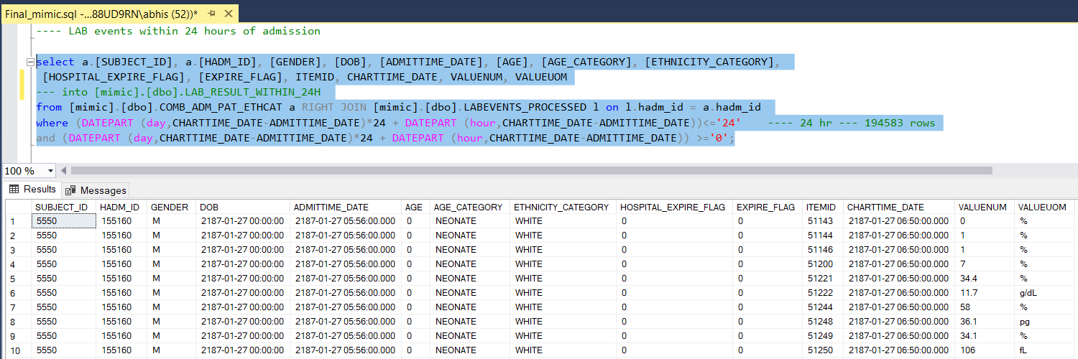

/* select a.[SUBJECT_ID], a.[HADM_ID], [GENDER], [DOB], [ADMITTIME_DATE], [AGE], [NEONATE], [ADULT], [SENIOR ADULT], [>89], [WHITE], [BLACK], [ASIAN], [HISPANIC/LATINO]

[DIAGNOSIS], [HOSPITAL_EXPIRE_FLAG], [EXPIRE_FLAG], ITEMID, CHARTTIME_DATE, VALUENUM, VALUEUOM

into [mimic].[dbo].LAB_RESULT_WITHIN_24H1

from [mimic].[dbo].COMB_ADM_PAT_ETHCAT1 a RIGHT JOIN [mimic].[dbo].LABEVENTS_PROCESSED l on l.hadm_id = a.hadm_id

where (DATEPART (day,CHARTTIME_DATE-ADMITTIME_DATE)*24 + DATEPART (hour,CHARTTIME_DATE-ADMITTIME_DATE))<='24' ---- 24 hr --- 194583 rows

and (DATEPART (day,CHARTTIME_DATE-ADMITTIME_DATE)*24 + DATEPART (hour,CHARTTIME_DATE-ADMITTIME_DATE)) >='0'; */

---- Distinct HADM_ID

select distinct(HADM_ID) from [mimic].[dbo].LAB_RESULT_WITHIN_24H ---- 11778 rows

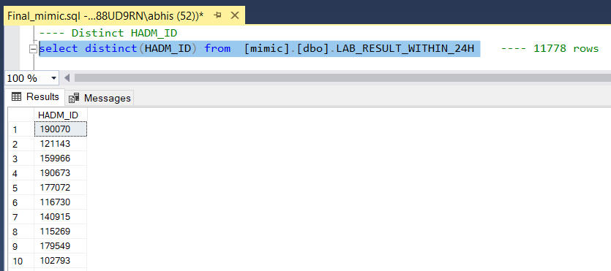

---- Distinct ITEM_ID

select TOP 25 [ITEMID], count([ITEMID]) as count INTO [mimic].[dbo].temp1 from [mimic].[dbo].LAB_RESULT_WITHIN_24H group by [ITEMID] ORDER BY count([ITEMID]) desc ---- 25 rows

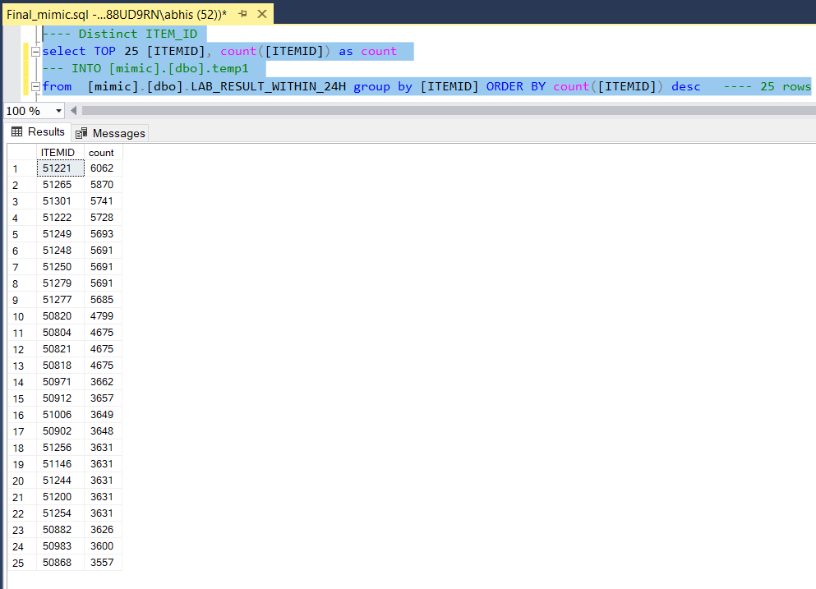

--- Combining with D_LabItems Table to get Labtest labels.

Select d.ITEMID, t.count, d.[LABEL]

from [mimic].[dbo].D_LABITEMS d

INNER JOIN

[mimic].[dbo].temp1 t

ON t.ITEMID = d.ITEMID

ORDER BY t.count desc; --- 25 rows

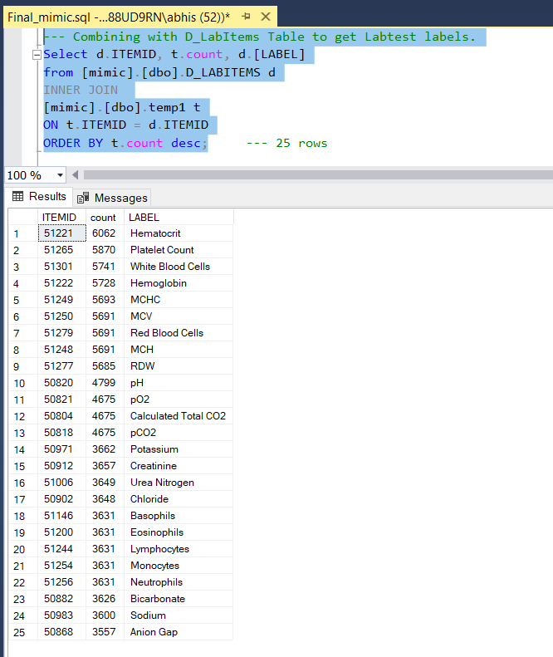

--- Top 25 most common item id from Lab Results for first 24 hrs

Select * INTO [mimic].[dbo].SELECT_ITEMID_24H

from [mimic].[dbo].LAB_RESULT_WITHIN_24H where ITEMID IN (51221,51265,51301,51222,51249,51279,51248,51250,51277,50820,

50821,50804,50818,50971,50912,51006,50902,51256,51254,51146,51200,51244,50882,50983,50868); ---114230 rows

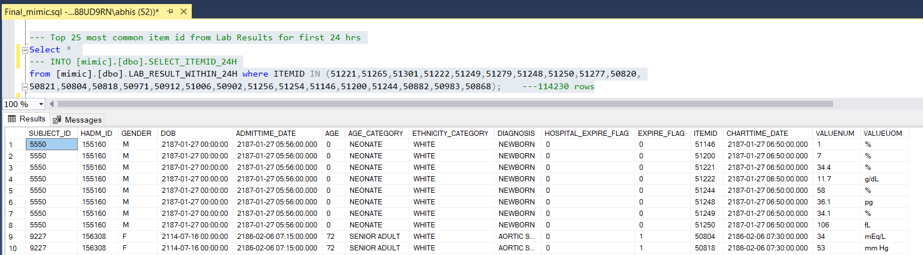

Select * INTO [mimic].[dbo].SELECT_ITEMID_24H

from [mimic].[dbo].LAB_RESULT_WITHIN_24H where ITEMID IN (51221,51265,51301,51222,51249,51279,51248,51250,51277,50820,

50821,50804,50818,50971,50912,51006,50902,51256,51254,51146,51200,51244,50882,50983,50868);

---- Ignoring all other HADM_ID not associated with any of the above item ids

--- Select top 25 most common item ids, getting label from D_LABITEMS and generating pivot table

select [HADM_ID],

avg(CASE WHEN [ITEMID]=51221 THEN CAST(VALUENUM as DECIMAL(9,2)) ELSE null END) as HEMATOCRIT,

avg(CASE WHEN [ITEMID]=51265 THEN CAST(VALUENUM as DECIMAL(9,2)) ELSE null END) as PLATELET_COUNT,

avg(CASE WHEN [ITEMID]=51301 THEN CAST(VALUENUM as DECIMAL(9,2)) ELSE null END) as WHITE_BLOOD_CELLS,

avg(CASE WHEN [ITEMID]=51222 THEN CAST(VALUENUM as DECIMAL(9,2)) ELSE null END) as HEMOGLOBIN,

avg(CASE WHEN [ITEMID]=51249 THEN CAST(VALUENUM as DECIMAL(9,2)) ELSE null END) as MCHC,

avg(CASE WHEN [ITEMID]=51279 THEN CAST(VALUENUM as DECIMAL(9,2)) ELSE null END) as RED_BLOOD_CELLS,

avg(CASE WHEN [ITEMID]=51248 THEN CAST(VALUENUM as DECIMAL(9,2)) ELSE null END) as MCH,

avg(CASE WHEN [ITEMID]=51250 THEN CAST(VALUENUM as DECIMAL(9,2)) ELSE null END) as MCV,

avg(CASE WHEN [ITEMID]=51277 THEN CAST(VALUENUM as DECIMAL(9,2)) ELSE null END) as RDW,

avg(CASE WHEN [ITEMID]=50820 THEN CAST(VALUENUM as DECIMAL(9,2)) ELSE null END) as pH,

avg(CASE WHEN [ITEMID]=50821 THEN CAST(VALUENUM as DECIMAL(9,2)) ELSE null END) as pO2,

avg(CASE WHEN [ITEMID]=50804 THEN CAST(VALUENUM as DECIMAL(9,2)) ELSE null END) as CALCULATED_TOTAL_CO2,

avg(CASE WHEN [ITEMID]=50818 THEN CAST(VALUENUM as DECIMAL(9,2)) ELSE null END) as pCO2,

avg(CASE WHEN [ITEMID]=50971 THEN CAST(VALUENUM as DECIMAL(9,2)) ELSE null END) as POTASSIUM,

avg(CASE WHEN [ITEMID]=50912 THEN CAST(VALUENUM as DECIMAL(9,2)) ELSE null END) as CREATININE,

avg(CASE WHEN [ITEMID]=51006 THEN CAST(VALUENUM as DECIMAL(9,2)) ELSE null END) as UREA_NITROGEN,

avg(CASE WHEN [ITEMID]=50902 THEN CAST(VALUENUM as DECIMAL(9,2)) ELSE null END) as CHLORIDE,

avg(CASE WHEN [ITEMID]=51256 THEN CAST(VALUENUM as DECIMAL(9,2)) ELSE null END) as NEUTROPHILS,

avg(CASE WHEN [ITEMID]=51254 THEN CAST(VALUENUM as DECIMAL(9,2)) ELSE null END) as MONOCYTES,

avg(CASE WHEN [ITEMID]=51146 THEN CAST(VALUENUM as DECIMAL(9,2)) ELSE null END) as BASOPHILS,

avg(CASE WHEN [ITEMID]=51200 THEN CAST(VALUENUM as DECIMAL(9,2)) ELSE null END) as EOSINOPHILS,

avg(CASE WHEN [ITEMID]=51244 THEN CAST(VALUENUM as DECIMAL(9,2)) ELSE null END) as LYMPHOCYTES,

avg(CASE WHEN [ITEMID]=50882 THEN CAST(VALUENUM as DECIMAL(9,2)) ELSE null END) as BICARBONATE,

avg(CASE WHEN [ITEMID]=50983 THEN CAST(VALUENUM as DECIMAL(9,2)) ELSE null END) as SODIUM,

avg(CASE WHEN [ITEMID]=50868 THEN CAST(VALUENUM as DECIMAL(9,2)) ELSE null END) as ANION_GAP

into [mimic].[dbo].LAB_RESULT_WITHIN_24H_PIVOT

from [mimic].[dbo].SELECT_ITEMID_24H group by [HADM_ID] ---- 9677 rows

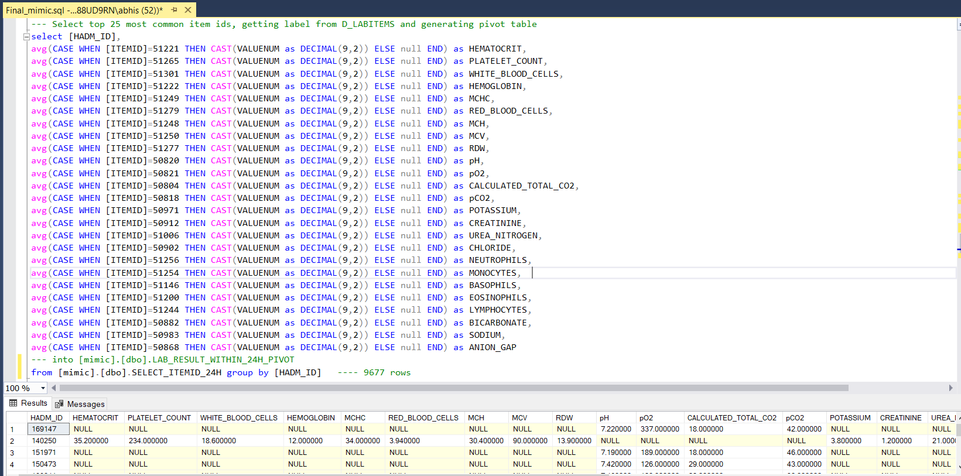

Select * from [mimic].[dbo].COMB_ADM_PAT_ETHCAT; ----- 45472 rows

SELECT * FROM [mimic].[dbo].LAB_RESULT_WITHIN_24H_PIVOT; ---- 9677 rows

---- Performing join on two files to make a single final csv file that can be dumped in Weka

select c.* , HEMATOCRIT, PLATELET_COUNT, WHITE_BLOOD_CELLS, HEMOGLOBIN, MCHC, RED_BLOOD_CELLS,

MCH, MCV, RDW, pH, pO2, CALCULATED_TOTAL_CO2, pCO2, POTASSIUM, CREATININE, UREA_NITROGEN, CHLORIDE,

NEUTROPHILS, MONOCYTES, BASOPHILS, EOSINOPHILS, LYMPHOCYTES, BICARBONATE, SODIUM, ANION_GAP

---INTO [mimic].[dbo].FINAL_TO_WEKA

from [mimic].[dbo].COMB_ADM_PAT_ETHCAT c

INNER JOIN

[mimic].[dbo].LAB_RESULT_WITHIN_24H_PIVOT l on c.hadm_id=l.hadm_id; ---- 9677 rows

---- View of the final file

Select * from [mimic].[dbo].FINAL_TO_WEKA;

